Node architecture and memory

LSTOPO

c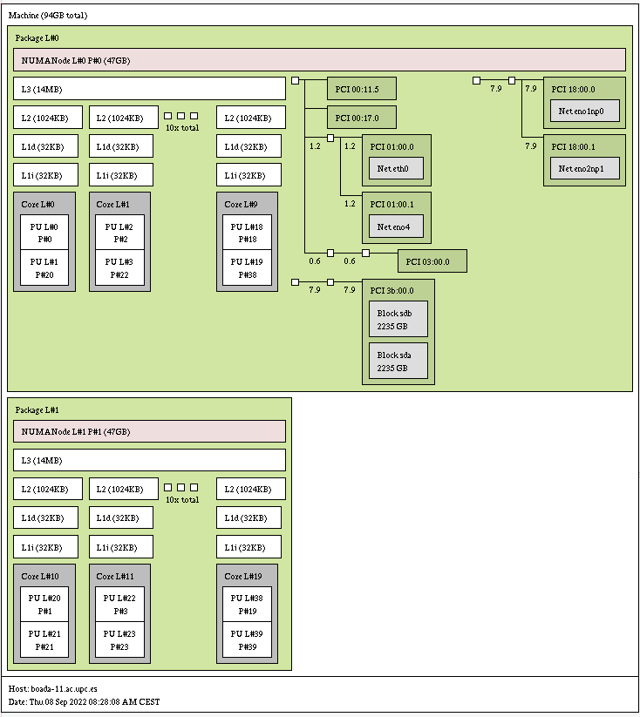

LSCPU

Architecture: x86_64

CPU op-mode(s): 32-bit, 64-bit

Address sizes: 46 bits physical, 48 bits virtual

Byte Order: Little Endian

CPU(s): 40

On-line CPU(s) list: 0-39

Vendor ID: GenuineIntel

Model name: Intel(R) Xeon(R) Silver 4210R CPU @ 2.40GHz

CPU family: 6

Model: 85

Thread(s) per core: 2

Core(s) per socket: 10

Socket(s): 2

Stepping: 7

CPU max MHz: 3200.0000

CPU min MHz: 1000.0000

BogoMIPS: 4800.00

Flags: fpu vme de pse tsc msr pae mce cx8 apic sep mtrr pge mca cmov pat pse36 clflush dts acpi mmx fxsr sse sse2 ss ht tm pbe syscall nx pdpe1gb rdtscp lm constant_tsc art arch_perfmon pebs bts rep_good nopl xtopology nonstop_tsc cpuid aperfmperf pni pclmulqdq dtes64 monitor ds_cpl vmx smx est tm2 ssse3 sdbg fma cx16 xtpr pdcm pcid dca sse4_1 sse4_2 x2apic movbe popcnt tsc_deadline_timer aes xsave avx f16c rdrand lahf_lm abm 3dnowprefetch cpuid_fault epb cat_l3 cdp_l3 invpcid_single intel_ppin ssbd mba ibrs ibpb stibp ibrs_enhanced tpr_shadow vnmi flexpriority ept vpid ept_ad fsgsbase tsc_adjust bmi1 avx2 smep bmi2 erms invpcid cqm mpx rdt_a avx512f avx512dq rdseed adx smap clflushopt clwb intel_pt avx512cd avx512bw avx512vl xsaveopt xsavec xgetbv1 xsaves cqm_llc cqm_occup_llc cqm_mbm_total cqm_mbm_local dtherm ida arat pln pts hwp hwp_act_window hwp_epp hwp_pkg_req pku ospke avx512_vnni md_clear flush_l1d arch_capabilities

Virtualization: VT-x

L1d cache: 640 KiB (20 instances)

L1i cache: 640 KiB (20 instances)

L2 cache: 20 MiB (20 instances)

L3 cache: 27.5 MiB (2 instances)

NUMA node(s): 2

NUMA node0 CPU(s): 0,2,4,6,8,10,12,14,16,18,20,22,24,26,28,30,32,34,36,38

NUMA node1 CPU(s): 1,3,5,7,9,11,13,15,17,19,21,23,25,27,29,31,33,35,37,39

Vulnerability Itlb multihit: KVM: Mitigation: VMX disabled

Vulnerability L1tf: Not affected

Vulnerability Mds: Not affected

Vulnerability Meltdown: Not affected

Vulnerability Mmio stale data: Mitigation; Clear CPU buffers; SMT vulnerable

Vulnerability Retbleed: Mitigation; Enhanced IBRS

Vulnerability Spec store bypass: Mitigation; Speculative Store Bypass disabled via prctl and seccomp

Vulnerability Spectre v1: Mitigation; usercopy/swapgs barriers and __user pointer sanitization

Vulnerability Spectre v2: Mitigation; Enhanced IBRS, IBPB conditional, RSB filling

Vulnerability Srbds: Not affected

Vulnerability Tsx async abort: Mitigation; TSX disabled

Serial compilation and execution

par2315@boada-7:~/lab1/pi$ ./run-seq.sh pi_seq 1000000000

Number pi after 1000000000 iterations = 3.141592653589828

Execution time (secs.): 2.558195

2.55user 0.00system 0:02.56elapsed 99%CPU (0avgtext+0avgdata 2232maxresident)k

0inputs+0outputs (0major+94minor)pagefaults 0swaps

Strong vs. weak scalability

